INFORMATION SYSTEMS III
2 HOURS MODULE B: DATABASE SYSTEMS 100 MARKS
(Memorandum)

QUESTION 1 (10 MARKS)
For each of the following questions, indicate whether the statement is True or False.

  - The reason for generating, storing, and managing data is to create information that becomes the basis for rational decision making. (True)

1.2 A new data storage facility, called a data store, has been developed to overcome DSS difficulties. (False)

1.3 A DSS operator might want to compare the relative rates of productivity growth by company division over some specific period of time, without defining any relationship between advertising types and sales levels. (False)

  - DSS data represents transactions as they happen, while operational data are a snapshot of the data at a given point in time. (False)

1.5 By non-volatile, Bill Inmon means that once data enter the data warehouse they are never removed. (True)

1.6 Given the current business and global information environment, it’s easy to see why many database professionals consider the DBMS connection to the Internet to be a non-critical element in IS development. (False)

1.7 Coldfusion is one of a new breed of products known as “Web application servers”. (True)

  - Usually, the native database connectivity interface provided by the vendor is not the only way to connect to a database; most current DBMS products support other database connectivity standards, the most common being ODBC. (True)

  - The CGI is a newer Web-server interface standard that is much more efficient and faster than a dynamic link library. (False)

  - An API uses script files that perform specific functions on the client’s parameters that are passed to the Web server. (False)

QUESTION 2 (8 MARKS)

While working as a database analyst for a national sales organization, Alpha-Omega Business Solutions, you are asked to be part of its data warehouse project team. Your data warehousing project team are arguing about prototyping a data warehouse before it is implemented. The project group members are especially concerned about the need to acquire some data warehousing skills before implementing the enterprise-wide data warehouse. What would you recommend? Explain your recommendations.

Proposed Answer:

Knowing that data warehousing requires time, money, and considerable managerial effort, many companies create data marts, instead. Data marts use smaller, more manageable data sets that are targeted to fit the special needs of small groups within the organization. In other words, data marts are small, single-subject data warehouse subsets. Data mart development and use costs are lower and the implementation time is shorter. Once the data marts have demonstrated their ability to serve the DSS, they can be expanded to become data warehouses or they can be migrated into larger existing data warehouses.

QUESTION 3 (45 MARKS)

Hannibal Import and Export background:

Hannibal Import and Export PTY (Ltd.) are an import and Export Company in Cape Town that specialises in the exporting of precious metals (bronze, silver, gold dust, gold bullion and platinum). They started their business during 1992 and during 1998 they acquired two franchises, one in Namibia and one in Botswana. The following information is kept for each export product: a unique ID; branch; metal type; the commodity agent assigned to that product; quantity; price per kg; quality; origin; discount; agent’s commission. Each franchise office has two branches. Each commodity product must be listed with only one agent. An agent may have a number of products listed, or may have no products listed. Each agent is assigned to a specific branch. More than one owner can own a product (precious metal). An owner can be an individual or a business.

  - You are required to develop the star schema for the above problem. (15)

Proposed Answer:
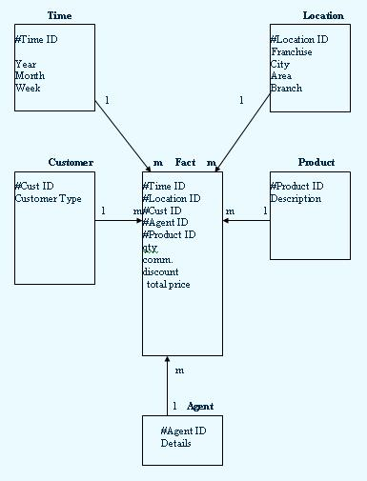
  - Given these brief notes, create the E-R diagram. Make sure you include all appropriate entities and relationships and define all connectivities, cardinalities and relationship participation. (20)

Proposed Answer:

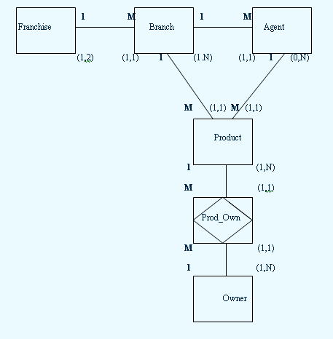

  - Consider the Star Schema given below (See Figure 13.17). Explain with the aid of a diagram how you could normalize one of the dimensions to achieve a more efficient structure and less storage. (10)

NB: Please write your assumptions before answering the above questions if there is any uncertainty.

Proposed Answer:
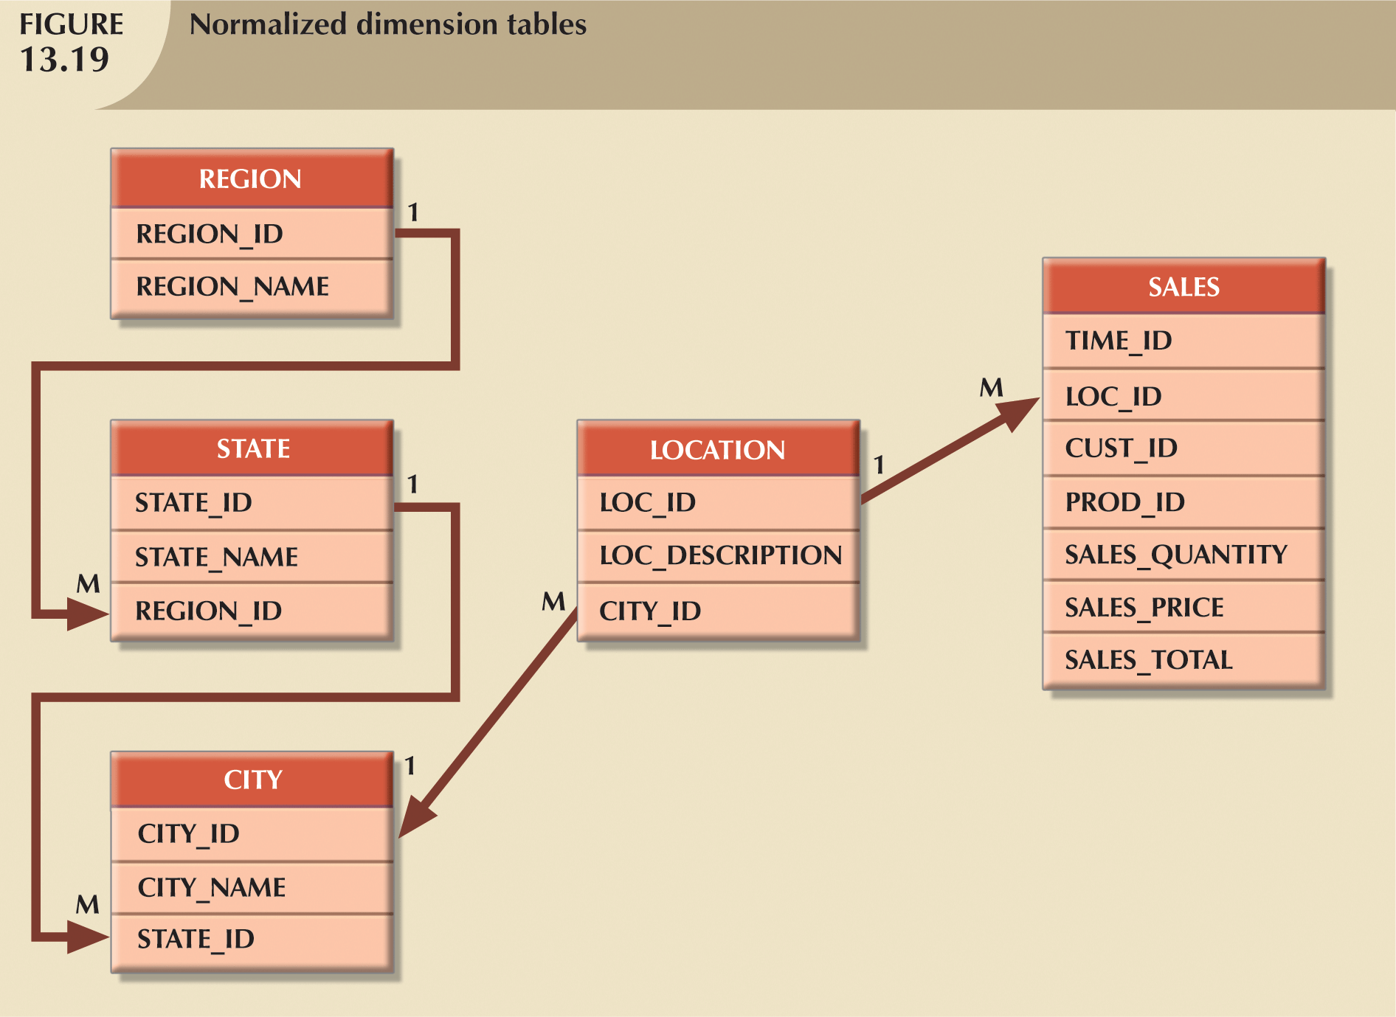

OR use TIME dimension

QUESTION 4 (12 MARKS)

First Bank has always been on the frontline of all banking institutions with technology and market changes. Due to a need to rapidly analyze great amounts of data and their growth during 2003/2004 they have appointed you as a decision support specialist to lead a team, who will develop their decision support system. First Bank believes that this will give them the competitive advantage and will give good market positioning.

The directors of First Bank have now called you into their meeting to show them how the main components of the Decision Support System are constructed. They have requested that you make use of an illustration as a visual presentation and also give short descriptions of what these components entail.

Proposed Answer:

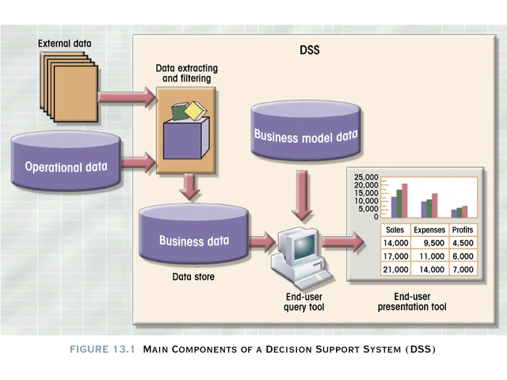

QUESTION 5 (25 MARKS)

  - Explain the term database Server-Side Extension (4)

Proposed Answer:

- Also known as Web-to-database middleware
- Program that interacts directly with Web server to handle specific types of requests
- Provides its services to Web server in way that is totally transparent to client browser

  - Describe the processes that typically take place, when an End-User on a client computer requests data from a database on the Internet via a Web Server. Define clearly any terms that you use (e.g. like CGI). Use a diagram to illustrate the entire process. (16)

Proposed Answer:

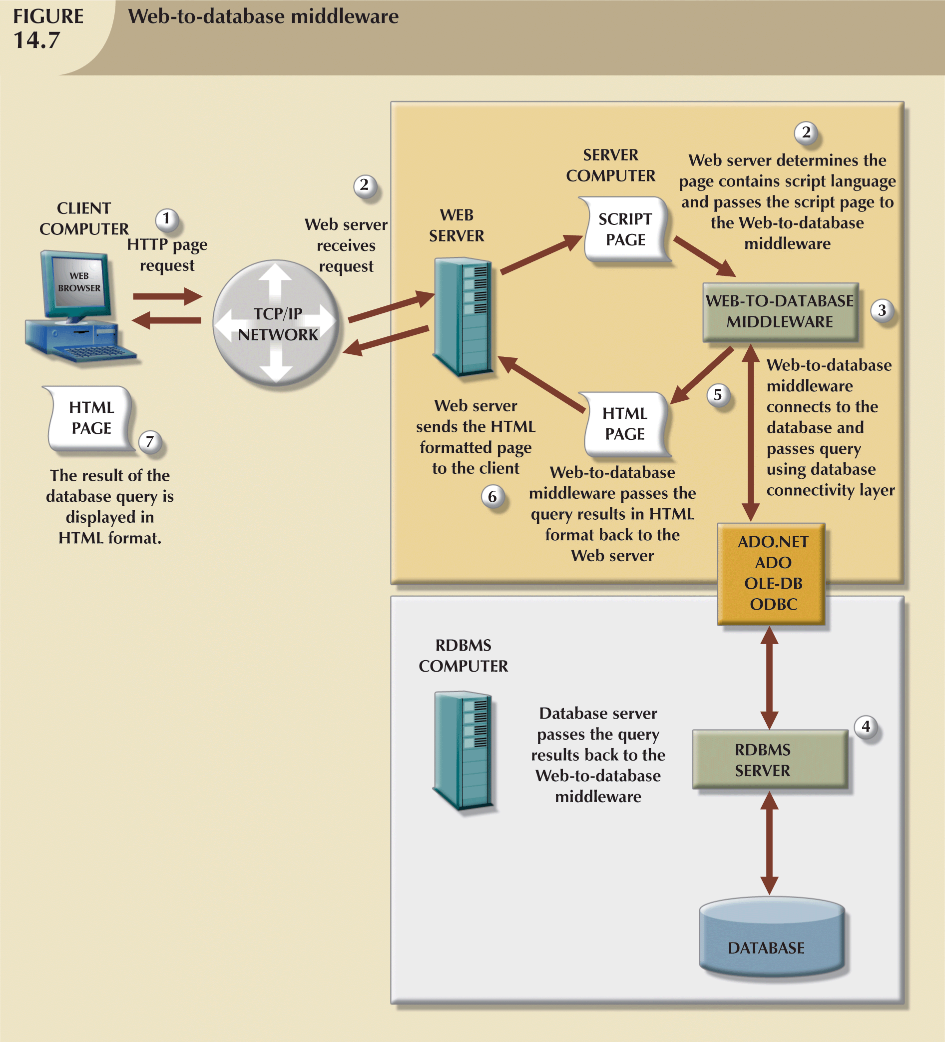

  - What is Microsoft’s Data Access Objects (DAO)? (5)

Proposed Answer:
- Data Access Objects (DAO) is an object oriented API used to access MS Access, MS FoxPro and dBase databases (using the Jet data engine) from Visual Basic programs. DAO provided an optimized interface that exposed the functionality of the Jet data engine (on which MS Access database if based on) to programmers. The DAO interface can also be used to access other relational style data sources.

